**Algorithms – Practical 8**

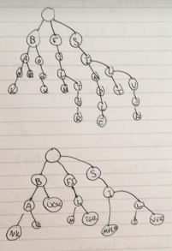**Part 1**